Vine School Health Center

**220 Langland Street Knoxville, TN 37915**

**Phone: 865-594-5078**

**Fax: 865-594-3921**

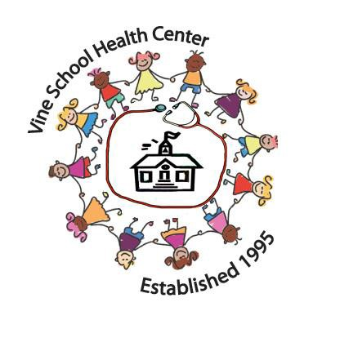VISION

Healthy students are students ready to learn.

MISSION

Vine School Health Center is a school-based

physical and mental health center located

behind the Vine Middle Magnet School in

Knoxville. Vine School Health Center is a joint

collaboration between Knox County School System and University of Tennessee College of Nursing**. Our mission is to provide comprehensive care to improve the overall physical, mental, and educational health for children living in Knox County.**

MEDICAL SERVICES

* Telehealth services with 14 Knox County schools with additional weekly on-site services
* Physical Examinations/EPDST Examinations
* Well child exam & Immunizations
* Medication Management
* Common illnesses—sick children seen on the same day
* Chronic disease management & Health and nutritional treatment
* Nurse practitioner on-call 24/7

MENTAL HEALTH SERVICES

* Mental Health Diagnostic Assessments
* Weekly & Bi-weekly Counseling Services
* Play Therapy counseling for children/adolescents
* Individual counseling for children/adolescents
* Family counseling
* Common areas of need: trauma, depression, anxiety, school challenges, behavioral issues, relationship concerns, etc.
* Case management at partnering Knox Co. School locations
* Family assistance with obtaining insurance
* Family assistance with obtaining local resources

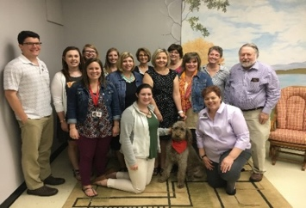

HOLISTIC CARE FOR ALL KNOX COUNTY CHILDREN

HOURS

Monday – Friday

8:00am-4:30pm

# STAFF

# **Pediatric Nurse Practitioners**

Tami Bland DNP, CPNP

Nan Gaylord PhD, CPNP

Katie Willard MSN, CPNP

Carney Ivy MSN, CFNP

Robert Cornette, DNP, CPNP

Carly Weaver, MSN, CPNP

**Mental Health Professionals**

Rachel Ross LCSW, RPT-S

Corey Olson, LCSW, RPT

**Registered Nurse**

Cathy Strysniewicz BSN, RN

### Office Manager

Natalie McConkey

Renetta Sheadrick

**Physician Support Services**

Larry Rodgers MD, FAAP

**Hospital Collaborator**

East Tennessee Children’s Hospital

We serve as an internship placement for the University of Tennessee undergraduate & graduate nursing and social work programs.

KNOX COUNTY STUDENTS SERVED

During the 2016-2017 academic year we had:

* 4,455 Physical health visits
* 2,064 Mental health visits
* 1,896 Vaccines administered
* 185 Resource & Insurance assistance visits
* 48 families obtained insurance with VSHC assistance
* 90 % of our patients are considered underserved